FOR IMMEDIATE RELEASE

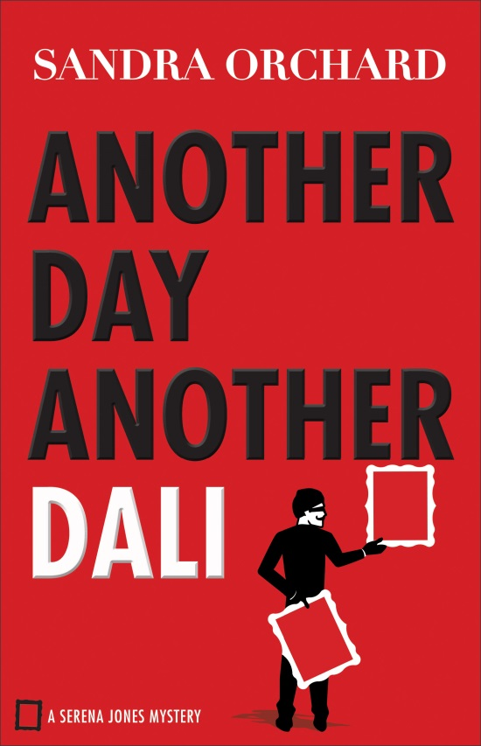
Another Day, Another Dali
By Sandra Orchard
9780800726690
$14.99
Paperback
352 pages
Pub Date: October 2016

For Publicity Contact:
Karen Steele
(616) 676-9185 x100
ksteele@bakerpublishinggroup.com

Revell, a division of Baker Publishing Group, publishes books that help bring the Christian faith to everyday life. Whether through fiction, Christian living, self-help, marriage, family, or youth books, each Revell publication reflects relevance, integrity, and excellence. For more information, please visit www.revellbooks.com.

Another Day, Another Dali

FBI Special Agent Serena Jones finds herself on another high-stakes case when a valuable Salvador Dali painting belonging to her grandmother’s friend is mysteriously replaced by a forgery.

Serena hopes that finding the thief and cracking the case will also mean that she finally measures up to Nana’s expectations. But when the evidence starts pointing to members of the owner’s own household, it becomes more and more clear that Serena won’t be winning any popularity contests.

The Dali isn’t the only painting that’s been replaced by the thief, raising the specter of a sophisticated theft ring–one with links to dirty cops, an aspiring young artist, and the unsolved murder of Serena’s grandfather. As the case builds and shocking evidence piles up, Serena must get to the bottom of the mystery for the sake of art and her family.

Orchard keeps readers on the edge of their seats as she sends them racing through the pages of the second thought-provoking whodunnit of the Serena Jones Mystery series.

Sandra Orchard is the award-winning author of many inspirational romantic suspense and mysteries, including Deadly Devotion, Blind Trust, and Desperate Measures. Her writing has garnered several Canadian Christian Writing Awards, a Romantic Times Reviewers' Choice Award, a National Readers' Choice Award, a HOLT Medallion Award of Merit, and a Daphne du Maurier Award for Excellence in Mystery/Suspense. In addition to her busy writing schedule, Sandra enjoys speaking at events and teaching writing workshops. She lives in Ontario, Canada. Learn more about Sandra's books and check out the special bonus features, such as deleted scenes and location pics, at http://sandraorchard.com.

Praise for A Fool and His Monet

"Completely delightful! A Fool and His Monet is laugh-out-loud funny! Readers who love Stephanie Plum will delight in Serena Jones. An engaging and charming read--I can't wait for more!" Susan May Warren, RITA Award-winning and bestselling author of the Christiansen Family series

