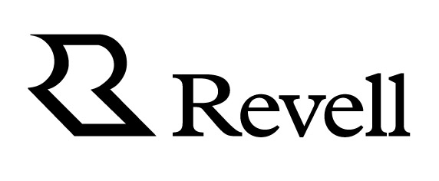
FOR IMMEDIATE RELEASE

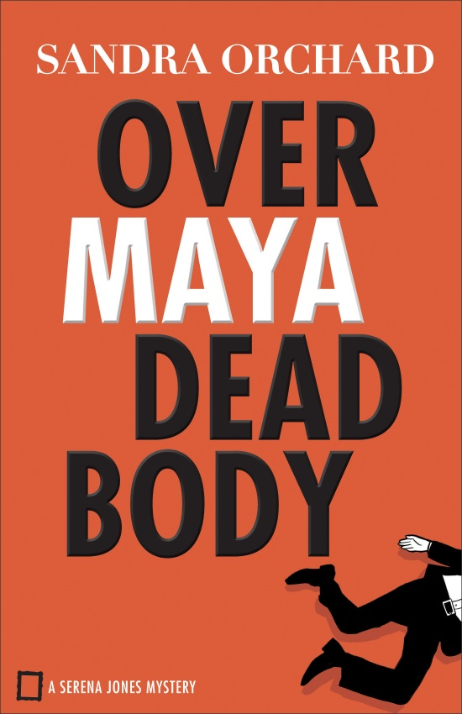
Over Maya Dead Body
By Sandra Orchard
9780800726706
$14.99
Paperback
352 pages
Pub Date: July 2017

For Publicity Contact:
Karen Steele
(616) 676-9185 x100
ksteele@bakerpublishinggroup.com

Revell, a division of Baker Publishing Group, offers practical books that bring the Christian faith to everyday life. Whether through fiction, Christian living, self-help, marriage, family, or youth books, each Revell publication reflects relevance, integrity and excellence.
For more information, visit www.RevellBooks.com.
New High-Stakes Case Sends FBI Special Agent Racing to the Rescue Before More Lives are Claimed
"This intriguing look into the world of art theft from the perspective of an FBI agent will keep readers guessing.”
—RT Book Reviews on A Fool and His Monet
Art crime, dangerous territory, and a complicated romance makes for another page-turning Serena Jones Mystery. Sandra Orchard ends her comical mystery series with a bang with the release of Over Maya Dead Body.
FBI Special Agent Serena Jones heads to Martha’s Vineyard for a bit of R&R and to help celebrate the engagement of a family friend. But crime doesn’t take a vacation, and she’s soon entangled in the investigation of a suspicious death tied to an antiquities smuggling ring. Serena finds her picture-perfect trip interrupted and an investigation awaiting her expertise. Before long she is propelled into danger and must act fast, before anyone else dies.
Her investigation is difficult enough as it is, so how is she supposed to handle two men in her life arriving on the scene and bringing with them romantic complications and even a secret or two?
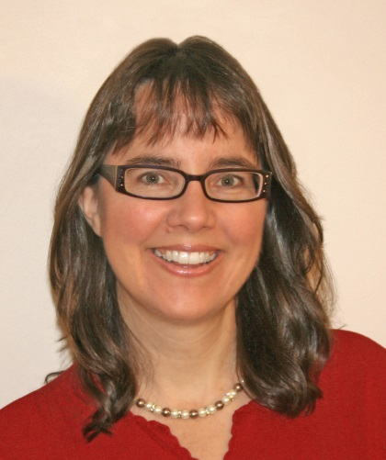
Sandra Orchard is the award-winning author of many inspirational romantic suspense and mysteries, including Deadly Devotion, Blind Trust, and Desperate Measures. Her writing has garnered several Canadian Christian Writing Awards, a Romantic Times Reviewers' Choice Award, a National Readers' Choice Award, a HOLT Medallion Award of Merit, and a Daphne du Maurier Award for Excellence in Mystery/Suspense. In addition to her busy writing schedule, Sandra enjoys speaking at events and teaching writing workshops. She lives in Ontario, Canada. Learn more about Sandra's books and check out the special bonus features, such as deleted scenes and location pics, at http://sandraorchard.com.

